**Virtual Reality Project**

**Feasibility Study**

**VR-Hand Eye**

For my 3rd year project I have decided to make a game within virtual reality. Virtual reality is still quite new and a modern with it only becoming mainstream popular in the last couple of years and I believe it could get even bigger in the next five or ten years where all PC and console games are played in virtual reality.

**Course-Specific Learning Outcomes**

* Be skilled and fluent in the use of structured computer programming techniques and demonstrate these skills though implementation of programmes.
* Develop skills in the use of graphics application interfaces (APIs) such as OpenGL and middleware tools and be able to use these to program/develop real-time, interactive 3D graphics for environments games.
* Apply design principles, use design methodologies and produce documentation for game specifications using industry standard approaches.
* Acquire a knowledge and understanding of behavioural systems most commonly employed in games design and be able to apply these appropriately.
* Understand the key technical problems and issues in three-dimensional modelling, rendering and animation and be able to monitor new developments in these areas.
* Implement systems and frameworks that demonstrate that they are a competent user of the mathematical tools and techniques used in three-dimensional computer graphics and in game physics.
* Appreciate the characteristics and features of a variety of game genres and be able to relate games design to broader media, art and culture.
* Be able to work as a team member and to understand the life-cycle management of a game development.
* Demonstrate effective communication, decision making and creative problem-solving skills, and identify appropriate practices within a professional, legal and ethical framework.

**Project Background**

Now although it is seen as something new and popular, virtual reality has been an idea for many decades, spanning way back to the 1950s. Morton Heilig, a pioneer in virtual reality, wrote in the 1950s of an "Experience Theatre" that could encompass all the senses in an effective manner, thus drawing the viewer into the onscreen activity.

The concept for my game will be where the user is in a small room and they must find a floating object within the room, every time they find that object it will teleport to a new random location within the room. There will also be objects that the user must avoid. The more objects they get the more points they will receive, hit the unwanted objects and the user will lose points. There is a one-minute time limit to keep the game short and sweet and keep the user interested.

The idea comes from hand-eye co-ordination tests that sports players and other professional industries use (see picture below).

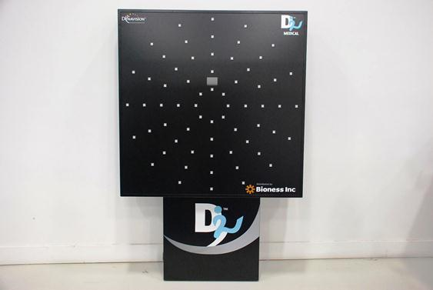

This machine has a timer on it and displays lights on buttons that the user must hit in a short amount of time. They must hit it within a certain time before it goes out and it increases with speed as the game goes on. As my game is in virtual reality and I want to reduce motion sickness I don’t necessarily want the game to be too fast.

**Aim**

The aim of the project for me is to make a unique game that stands out to customers or clients.

**Objectives**

My objectives are:

* To research about existing hand-eye co-ordination games and the algorithm for randomisation.
* To create customised algorithms and mathematical equations to generate a randomised spawn for objects within the hand-eye co-ordination game.
* To produce a novel game to improve hand-eye co-ordination and sharpening reflexes.
* To investigate if this hand-eye co-ordination game can be a game used within a general home environment for a visually impaired patient.

**Problems**

One of the problems that I’m hoping to avoid is that this game won’t cause motion sickness, virtual reality has been known to cause motion sickness with people as things can move so quickly or the brain is tricked into thinking the body is moving but it’s stationary. Also, my primary mobile device is an iPhone, but I have a Windows PC. To upload my game to my mobile I need a Mac operating system with XCode so I am borrowing an Android phone to be able to upload and test my game.

**Required Resources**

* Google cardboard
* iPhone with iOS 8 or above or an Android phone that has version 4.4 “KitKat” or above – the phone must also have a gyroscope in it
* USB cable to be able to connect the device to a PC
* To program the game Unity 2017.4 or above is required
* Not necessarily required but as a preference, headphones for in-game sound

**Schedule**

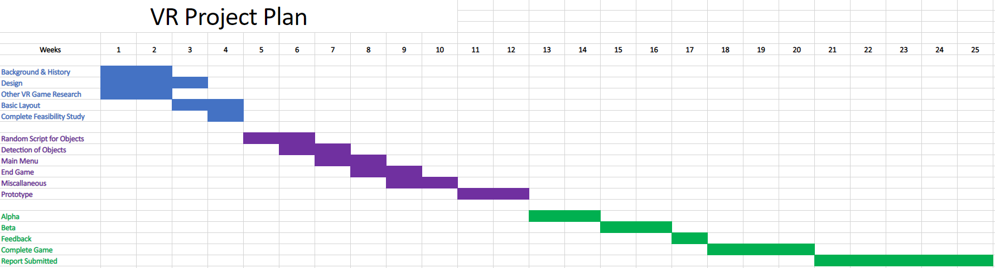

**Ethics Forms**

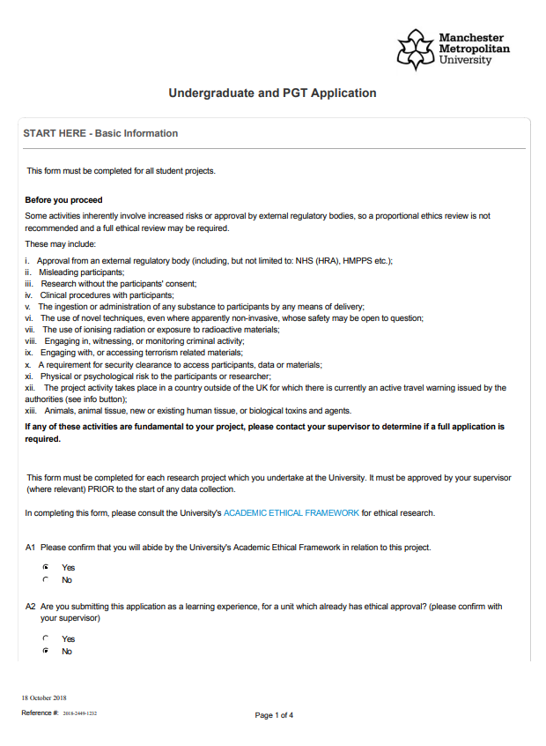

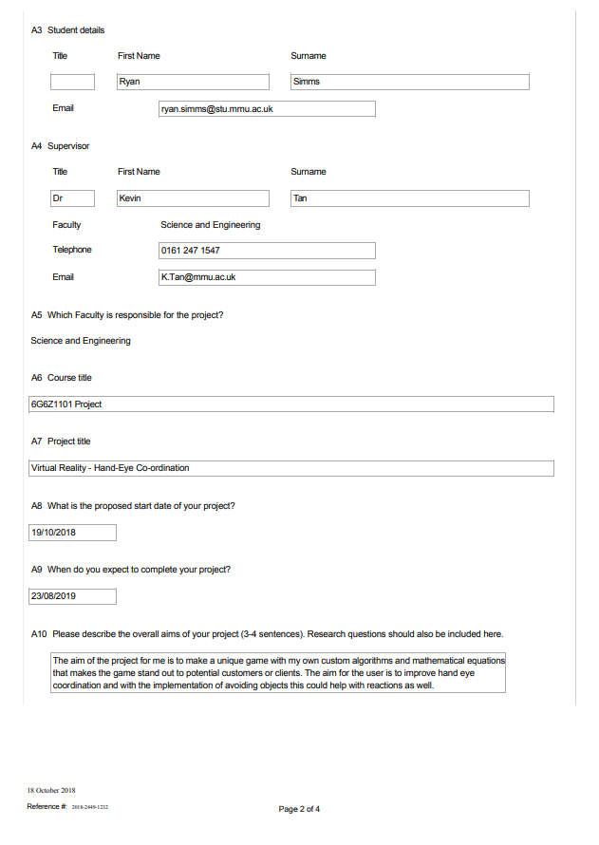

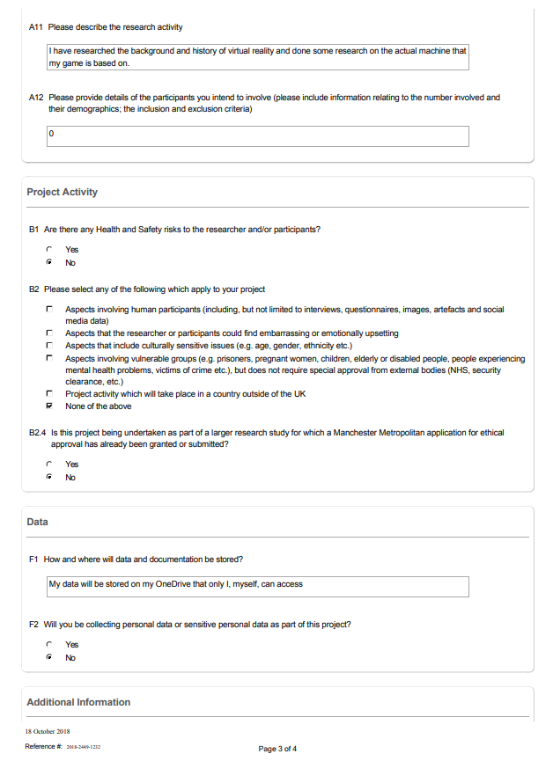

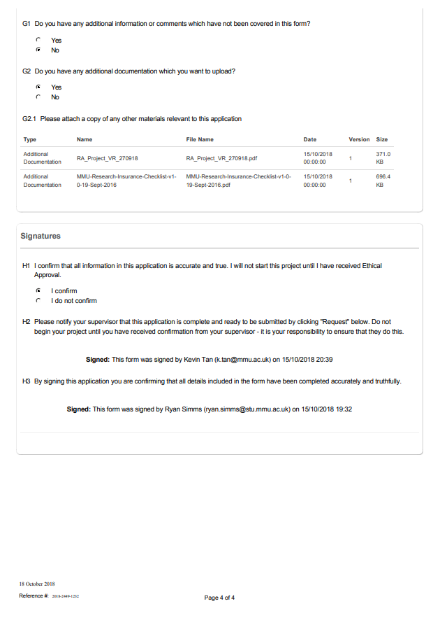

**Overview**

Manchester Metropolitan University holds insurance policies to cover claims for negligence arising from the conduct of the institution’s normal business. This includes research undertaken by undergraduate and postgraduate students as part of their academic qualification as well as research carried out by staff.

If you are an undergraduate student, postgraduate student or staff researcher at the institution, you must complete all relevant sections of the checklist on the following pages to identify whether your application requires referral to the university’s Insurance Officer.

Completing and submitting the checklist will ensure that your research study has appropriate insurance cover in place **before** it begins. Please submit your completed Research Insurance Checklist along with your Ethics Checklist and/or Application for Ethical Approval to your Faculty Research Officer.

**Referral to the Insurance Officer**

If your research falls into any of the categories listed in Section 2 and/or Section 3 of the checklist, the Faculty Research Officer will send the following information to the Insurance Officer at [insurance1@mmu.ac.uk](mailto:insurance1@mmu.ac.uk):

* Insurance Checklist
* Ethics Checklist and/or Application for Ethical Approval Form
* Participant Information Sheet(s) (if applicable)
* Participant Consent Form(s) (if applicable)
* Risk Assessment

The Insurance Officer will liaise with the insurers to gain approval. Please note some types of research may require additional insurance, which may incur an additional cost to the Faculty.

**Research studies must not commence until insurance and all other relevant authorisations and/or approvals are given.**

**Travel Insurance**

Manchester Metropolitan University has a policy to provide worldwide travel insurance for members of staff and students travelling in connection with their course or on an approved University trip. This includes travel undertaken in connection with undertaking a research study. You must complete the online travel insurance form to register for travel insurance and should do this at least two weeks before your departure date.

Please visit the [Financial and Legal webpage](https://www2.finance.mmu.ac.uk/services/?id=36&rootid=156&artId=162) for details.

**High Risk Countries**

Please visit the [AIG Travel Guard website](https://travelguard.secure.force.com/TravelAssistance/TGPreLoginHomePage?PL=null&startURL=/TravelAssistance/TGTravelSecurity) to identify whether the overall rating for the country you are travelling to is ‘High Risk’ or more severe. Please contact your Faculty Research Officer for guidance on accessing the relevant information on the website.

**ADMINISTRATIVE DETAILS**

**Lead Investigator Name** Click here to enter text.

**(Title/Forename/Surname)**

**Contact Email Address** Click here to enter text.

**Full Title of the Research**  Click here to enter text.

**SECTION 1 – TECHNIQUES, TESTING AND INTERVENTIONS**

Does your research study involve:

**Physically invasive techniques?**

This refers to any test in which the skin of the participant is broken or an implement is inserted into any opening of the human body (e.g. eyes, ears, nose, mouth, lungs, stomach, rectum, vagina and urethra) or involves the taking of body samples such as saliva, hair, urine, faeces, sputum, skin, nails, or taking biopsies of any form for any purpose, or any form of scanning such as DEXA scans, Ultrasound scans, MRI, fMRI, CT, or PET scanning.

**Ingestion of food stuffs or drugs?**

This refers to the consumption of any substance which may impact on psychological or physical state. Substances may include but are not limited to food, beverages or drugs.

**Physical testing?**

This refers to any test in which a participant must perform an action resulting in the use of any muscle of the body and/or involves the use of scanning procedures, eye-trackers, mounted body cameras, sensors or electrodes, or the taking of swabs from any cavity of the body, respiratory challenge testing or recording of peak flows, EEG, ECG, Exercise ECG, Treadmill work.

**Psychological intervention?**

This refers to any test which purposely alters the mood of the participant or involves administering personality inventories, or any other form of psychological test.

***OR***

**I confirm that my research does not fall into any of the above categories *(please***

***go straight to Section 3)***

**SECTION 2 – CLINICAL TRIALS INSURANCE**

**Please complete this section only if you ticked one of the boxes in Section 1**.

Does your research study involve:

**Pregnant persons as participants with** **procedures other than blood samples**

**being taken from them?**

**Children aged five or under with procedures other than blood samples**

**being taken from them?**

**Activities being undertaken by the lead investigator or any other member of**

**the study team in a country outside of the UK? *If ‘Yes’, please refer to the ‘Travel Insurance’ guidance on Page 1 of this form.***

***OR***

**I confirm that my research does not fall into any of the above categories**

**SECTION 3 – OTHER HAZARDS**

Does your research study involve:

**Working with Hepatitis, Human T-Cell Lymphotropic Virus Type iii (HTLV iii), or**

**Lymphadenopathy Associated Virus (LAV) or the mutants, derivatives or variations thereof or Acquired Immune Deficiency Syndrome (AIDS) or any syndrome or condition of a similar kind?**

**Working with Transmissible Spongiform Encephalopathy (TSE), Creutzfeldt-Jakob**

**Disease (CJD), variant Creutzfeldt-Jakob Disease (vCJD) or new variant Creutzfeldt-Jakob Disease (nvCJD)?**

**Working in hazardous areas or high risk countries? *Please refer to the ‘High Risk***

***Countries’ guidance on Page 1 of this form.***

**Working with hazardous substances outside of a controlled environment?**

**Working with persons with a history of violence, substance abuse or a criminal**

**record?**

***OR***

**I confirm that my research does not fall into any of the above categories**

Version 1.0 July 2011

**The MANCHESTER METROPOLITAN UNIVERSITY**

**Faculty of Science and Engineering**

**RISK ASSESSMENT COVER SHEET**

|  |  |  |  |
| --- | --- | --- | --- |
| **REFERENCE NUMBER**: NPC / 270918 / JDE1.49 | | | |
| **SCHOOL: Computing, Mathematics & Digital Technology** | | | |
| **TITLE OF WORK:** CMT Projects involving software development only including Virtual Reality (VR) headsets | | | |
| **LOCATION OF WORK:** John Dalton Building computing facilities, computers at student’s own home etc. | | | |
| **INTENDED ACTIVITIES** (attach methods sheets (e.g. standard operating practices) and work schedules to this form):  General use of computers to develop and test software. Method sheets and work schedules not applicable. | | | |
| **PERSONS AT RISK** (list names of all individuals (including status e.g. staff/student), and/or unit(s) / course(s) undertaking the activity. For students please indicate course and level, for staff give contact email / phone number):  Undergraduate students. | | | |
| **HAZARDS** (provide a summary of the hazards anticipated and attach detailed assessments with appropriate risk control methods to this form):  Repetitive Strain Injury – work related upper limb disorder  Back injury resulting from improper posture  Eye strain  Fatigue Stress  Possible risk from 240v electrical mains supply  VR headset: risk of colliding with surroundings when wearing headset – risk is mimimized by using headset under supervision only.  VR headset: risk of temporary dizziness or motion sickness – users should be instructed to remove headsets at the first sign of dizziness or sickness.  *Are these hazards necessary in order to achieve the objectives of the activity?*  **Yes**  **Hazard Rating** (delete as appropriate): **Low** | | | |
| **HAZARDOUS SUBSTANCES/MATERIALS USED AND HAZARD CLASSIFICATION**  **(**appropriate COSHH data sheets / risk assessments must be attached to this form**):**  **ALL CONTAINERS OF HAZARDOUS SUBSTANCES SHOULD BEAR CORRECT HAZARD WARNING LABELS***.* | | | |
| **NAME OF MATERIAL**  *Please provide also approximate quantity and concentration if applicable.* | **HAZARD CLASS** | **HAZARD LABEL** | **DISPOSAL**  *Hazardous materials must not be removed from laboratories. List disposal arrangements for* all materials listed below *in the location where* the work will be |

Version 1.0 July 2011

|  |  |  |  |  |  |  |
| --- | --- | --- | --- | --- | --- | --- |
|  |  | |  | | carried out: | |
|  |  | |  | |  | |
| **RISK CONTROL METHODS** (provide a summary of the hazards anticipated and attach detailed assessments with appropriate risk control methods to this form):  The hazards identified above are controlled by:  Facilities review when laboratories are commissioned  Induction session on H&S given to students by Technical Services Manager  School H&S information given in Student handbook  Posters in laboratories  PAT testing of equipment after three years  Annual H&S inspections  VR headsets to be used under supervision only, and to be removed if the users feels any dizziness or motion sickness.  *The laboratory workstations, whilst not legally required to be DSE compliant, (the continuous usage is too low to present risk) are fully compliant with current legislation. Monitors and keyboards are adjustable, chairs are adjustable and the lighting designed for both computer usage and associated reading activity. In each laboratory, there is an adjustable desk, suitable for wheelchair users, usually located in the next to the door.*  **Hazard Rating with Control Methods** (delete as appropriate): **Low** *Will any specific* **training** *be required (if* YES *give details)?* N/A  *Are there any specific* **first aid** *issues (if* YES *give details)?* N/A | | | | | | |
| **PROCEDURE FOR EMERGENCY SHUT-DOWN** (if applicable):  In the event of fire, flood or other emergency, evacuation of the laboratory would take place and the technical staff would subsequently make an assessment of the necessity of switch-off. As overall system control is vested in a separate server room, there would be little physical harm to any device in directly cutting the power to the mains for each individual lab.  Re-start of the lab may present problems of a technical nature but would not affect the personal safety or health of any individual. | | | | | | |
| **IF OFF-SITE INDICATE ANY OTHER ISSUES** (e.g. associated with: individual’s health and dietary  requirements (obtain off-site health forms for all participating individuals and indicate where this information will be located); social activities, transportation, ID requirements; permissions for access and sampling).  **Not applicable – this form applies only to the laboratories listed** | | | | | | |
|  | | **NAME** | | **STAFF/STUDENT No.** | | **DATE** |
| **Originator** | | Nicholas Costen | | 01900261 | | 27/09/18 |
| **Supervisor** | | N/A | |  | |  |
| **Technical Manager** | |  | |  | |  |
| **Divisional / School Health and Safety Coordinator (**p.p. HoS) | | https://i.gyazo.com/e6edf2f91c7b859a02b0394cba7e67cf.png | |  | |  |

Version 1.0 July 2011

**DATE TO BE REVIEWED BY: September 2019**